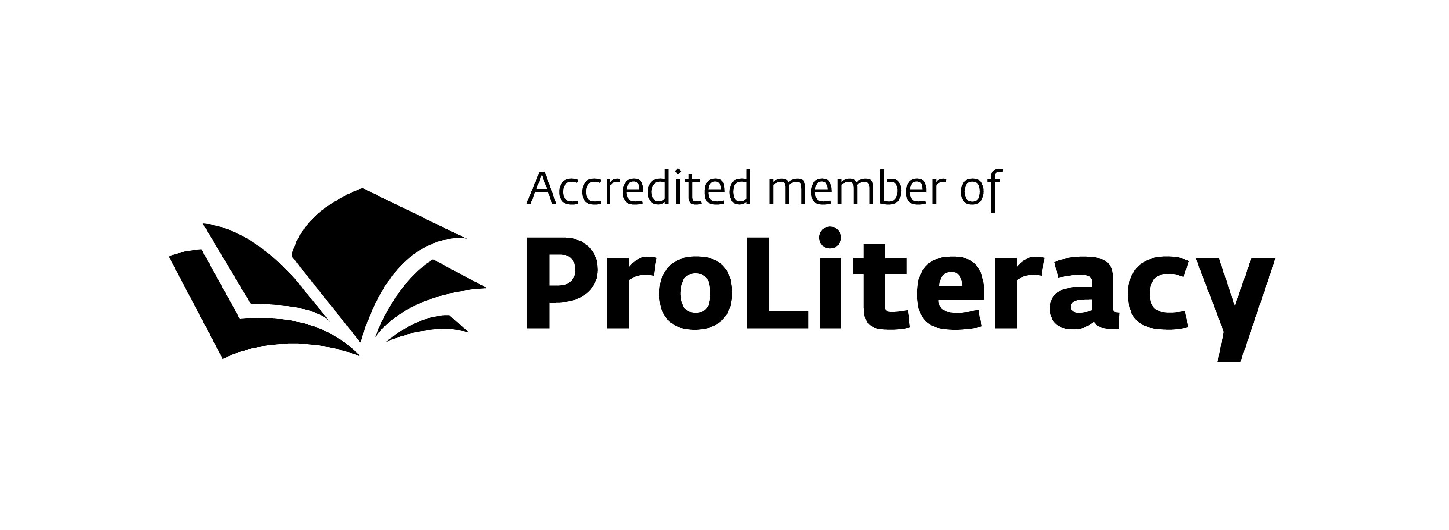
Literacy Volunteers of Camden County

Denise Weinberg Wendy Dawson Ginny Marcin
Director Coordinator of Basic Literacy Coordinator of English as a Second Language

For immediate release
Contact: Denise Weinberg (856) 772-1626 ext. 7331
dweinberg@camdencountylibrary.org

TD Charitable Foundation Supports Literacy Volunteers of Camden County

VOORHEES, NJ – July 24, 2014 - The TD Charitable Foundation, the charitable giving arm of TD Bank, America’s Most Convenient Bank®, recently awarded Literacy Volunteers of Camden County and Literacy Now a grant to fund an English as a Second Language (ESL) Conversation Class. This grant is a part of the foundation’s commitment to giving back to the community.

LVCC and its fundraising wing, Literacy Now, provide free one-on-one tutoring in reading, math and English as a Second Language to Camden County adults at the lowest levels of literacy. Many local residents lack functional English literacy skills and this impedes their ability to get a job, assist their children in school and become active community members.

“This grant will enable us to offer services to the local immigrant community beyond our free one-on-one tutoring instruction,” said Denise Weinberg, director of LVCC. “People studying English need opportunities to practice their language skills in a safe and nurturing environment. We have wanted to offer a Conversation Class for years, but could not obtain funding for the staffing and materials.” Weinberg hopes that the free evening classes will begin in the fall at the M. Alan Vogelson Regional Branch Library in Voorhees.

“We feel very fortunate to be building a partnership with TD Bank. It is gratifying that its Charitable Foundation recognizes the issue of illiteracy in our community and has chosen to support this project,” added Weinberg.

A staunch commitment to active involvement in the local community is a vital element of the TD Bank philosophy. TD Bank, America’s Most Convenient Bank® and the TD Charitable Foundation provide support for affordable housing, financial literacy and education, and environmental initiatives, many of which focus on improving the welfare of children and families.

For more information, call Literacy Volunteers of Camden County at 856 772-1636 ext. 7331.

About the TD Charitable Foundation
The TD Charitable Foundation is the charitable giving arm of TD Bank N.A., which operates as TD Bank, America’s Most Convenient Bank®, and is one of the 10 largest commercial banking organizations in the United States. The Foundation's mission is to serve the individuals, families and businesses in all the communities where TD Bank operates, having made $121.8 million in charitable donations since its inception in 2002. The Foundation’s areas of focus are affordable housing, financial literacy and education, and the environment. More information on the TD Charitable Foundation, including an online grant application, is available at www.TDBank.com.

About TD Bank, America's Most Convenient Bank®
TD Bank, America's Most Convenient Bank, is one of the 10 largest banks in the U.S., providing more than 8 million customers with a full range of retail, small business and commercial banking products and services at approximately 1,300 convenient locations throughout the Northeast, Mid-Atlantic, Metro D.C., the Carolinas and Florida. In addition, TD Bank and its subsidiaries offer customized private banking and wealth management services through TD Wealth®, and vehicle financing and dealer commercial services through TD Auto Finance. TD Bank is headquartered in Cherry Hill, N.J. To learn more, visit www.tdbank.com. Find TD Bank on Facebook at www.facebook.com/TDBank and on Twitter at www.twitter.com/TDBank_US.

TD Bank, America's Most Convenient Bank, is a member of TD Bank Group and a subsidiary of The Toronto-Dominion Bank of Toronto, Canada, a top 10 financial services company in North America. The Toronto-Dominion Bank trades on the New York and Toronto stock exchanges under the ticker symbol "TD". To learn more, visit www.td.com.

About Literacy Volunteers of Camden County
LVCC provides free one-on-one tutoring in reading, math and English for Speakers of Other Languages to Camden County adults at the lowest levels of literacy. Many local residents lack functional English literacy skills and this impedes their ability to acquire productive employment, assist their children in schoolwork and become active community members. LVCC, accredited by Proliteracy and Literacy New Jersey, addresses this problem by training local volunteers to instruct these adults using a flexible, learner-centered approach. Based in the Camden County Library System, LVCC currently has over 150 volunteer tutors working with 235 learners. http://lva.camdencountylibrary.org

# # #

